Big Mountain Resort Recommendations

Working through the data, we found that the current ticket price of Big Mountain Resort is too low. By analyzing the ticket prices of ski resorts across the country, we conclude that resorts like Big Mountain Resort are charging more per customer. Based on these findings, we recommend a new weekday ticket price of around $95.87.

The machine learning model we created allows us to see that there are good reasons for increasing the price. The final model determined that having a run with high vertical drop drove price up, and Big Mountain Resort has a rather large vertical drop.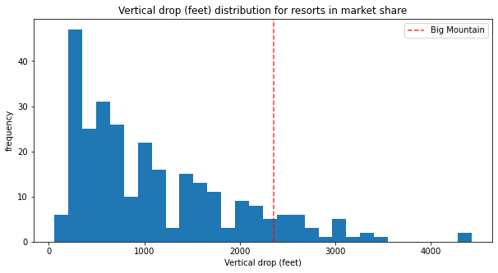

Another factor is total area covered by snow makers: again Big Mountain fairs well compared to competitors.

Finally, the total number of runs was also found to be an important factor in the price.

We conclude that the price given by the model is sensible.